Drakensberg Mountains South Africa

1) This was taken in the Tugela Gorge, following the Thukela river past protea trees (the national flower of South Africa), indigenous yellow wood forest and mountainous grassland into the heart of the Royal Natal National Park.

.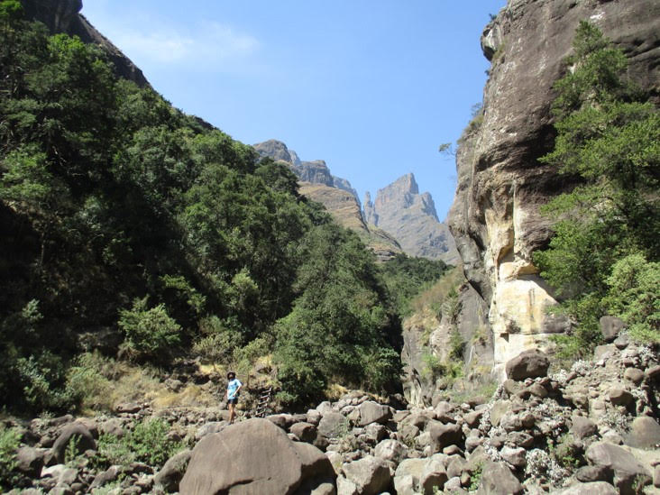

2) The hike to the Tugela Falls, the world’s second tallest waterfall, took us via this set of ladders.  Once up, we trekked across the 2,900m plateau following the river to look down on the waterfall

