Mallorca

1) One of the many cobbled coastal trails in the north of Mallorca which follow old postal routes and pilgrims’ trails through holm oak woods, orange groves and olive groves.

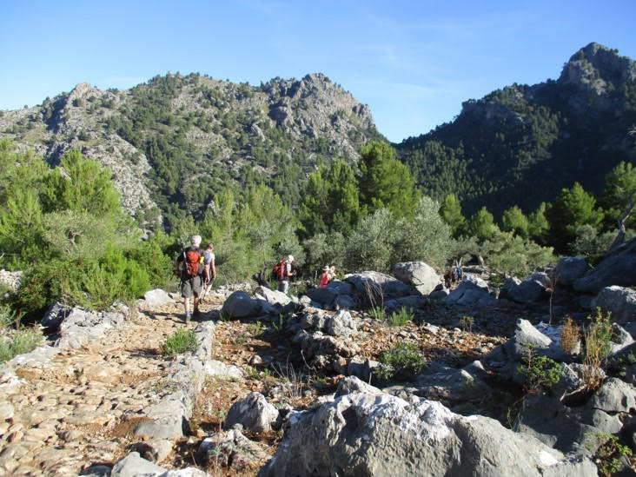

2) From Cuber reservoir we followed a track alongside to then climb the peak of L’Ofre, 1,113 metres.  We then took a long descent down an old pilgrim’s route of 1,000 stone steps which is now quite a famous walk.  The peak in the distance is unattainable due to military restrictions.

