Fife Mountaineering Club Newsletter December 2019

My general feeling about recent months is that it has been an Autumn of mixed weather with November being unusually cold. When I read the reports and look at the photos of the Club’s activities over the past three months they seem to fit this impression, with a beautiful cold sunny day on a snow covered Mount Keen in November but there were also two outings where what was planned was modified due to the conditions. The planned ascent of of Carn an Righ from the Spittal of Glen Shee turned into a walk on lower hills between Glen Prosen and Glen Isla but it did include an ascent of the Graham, Cat Law. On the most recent outing the group set out with the aim of climbing Ben Ledi in the Trossachs but low cloud and rain led to this objective being abandoned with a lower level walk along part of the Rob Roy Way taking in the Falls of Leni being the favoured alternative. In mid September Ben Lui and Beinn a’ Chleibh were climbed as planned on a walk that was wet and boggy underfoot. However the group were rewarded with the cloud clearing from Ben Lui just as they arrived at the summit. This luck was not repeated on either Beinn Tulaichean or Cruach Ardrain in mid October on a day which managed to be mostly dry but the cloud remained firmly on both tops.
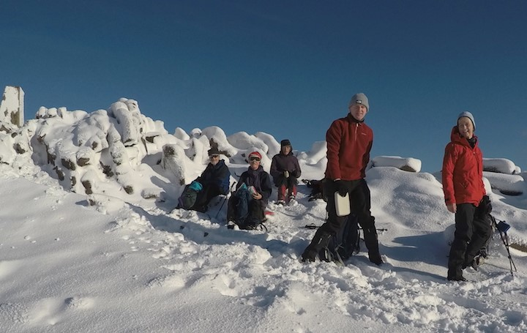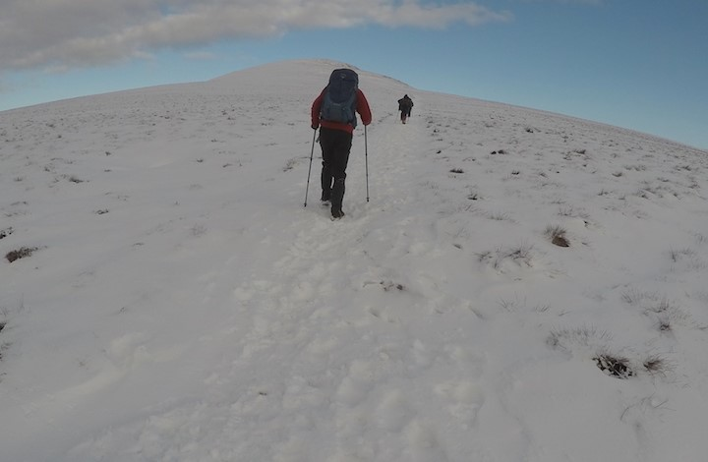
On Mount Keen
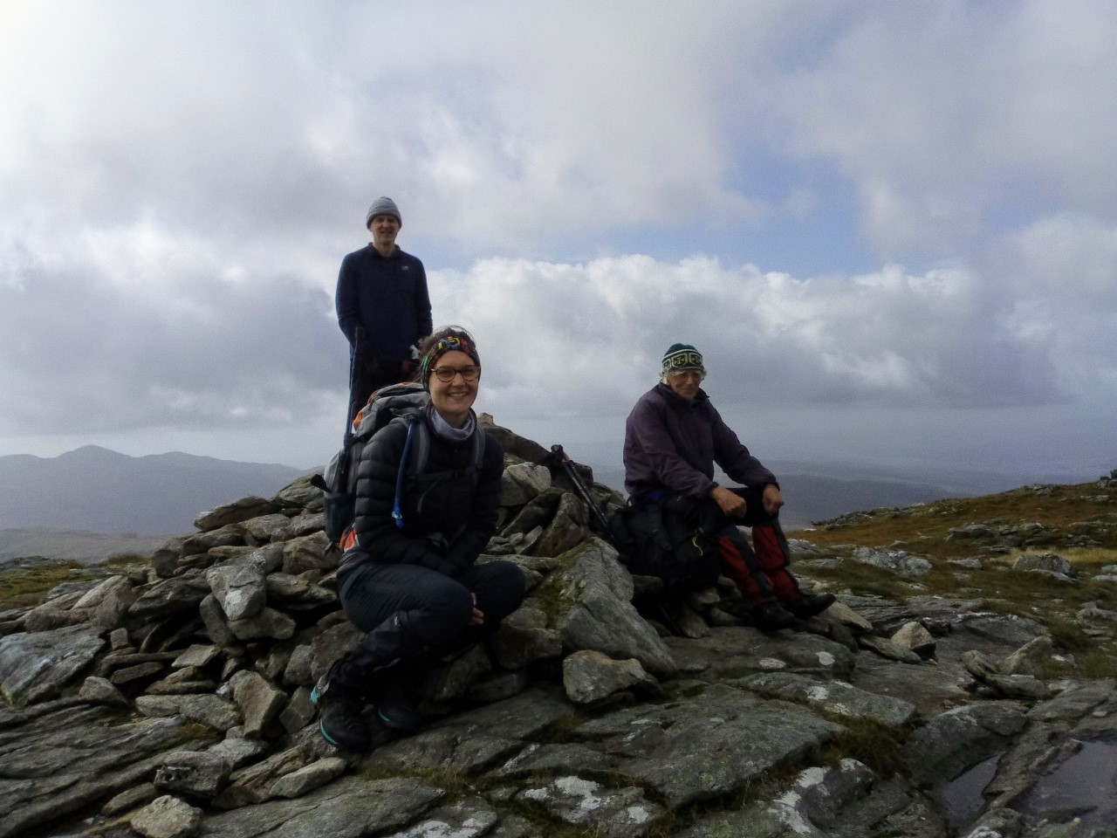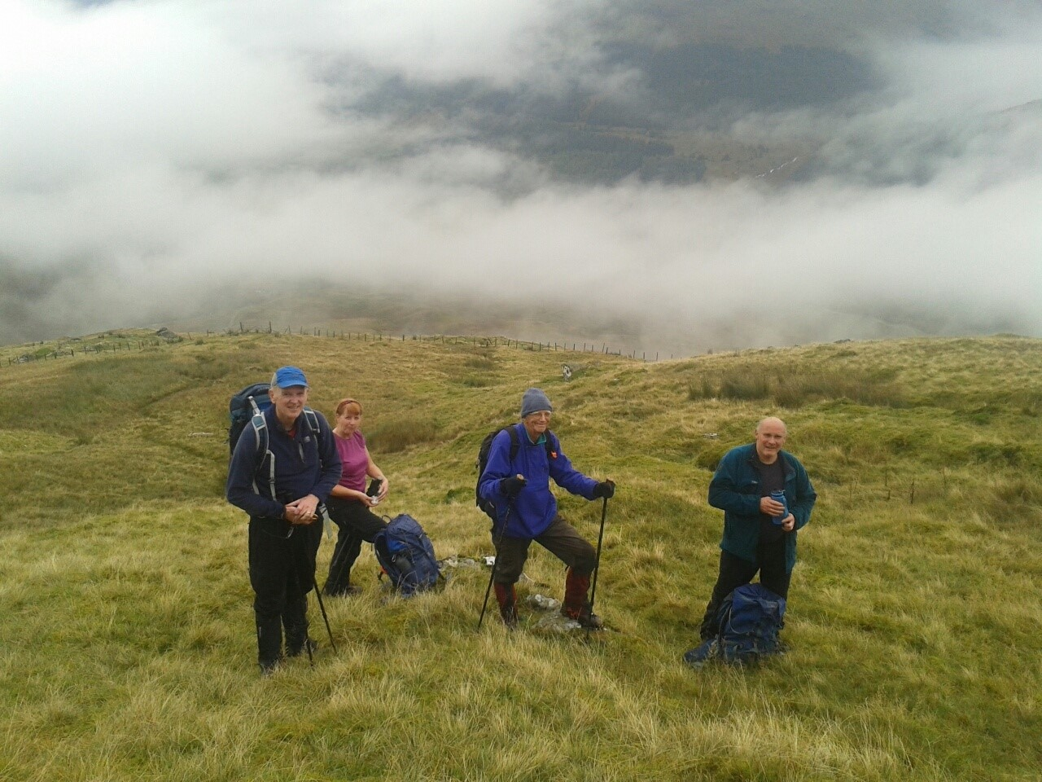 on Ben Lui (or Beinn a’ Chleibh) on Beinn Tulaichean (or Cruach Ardrain)
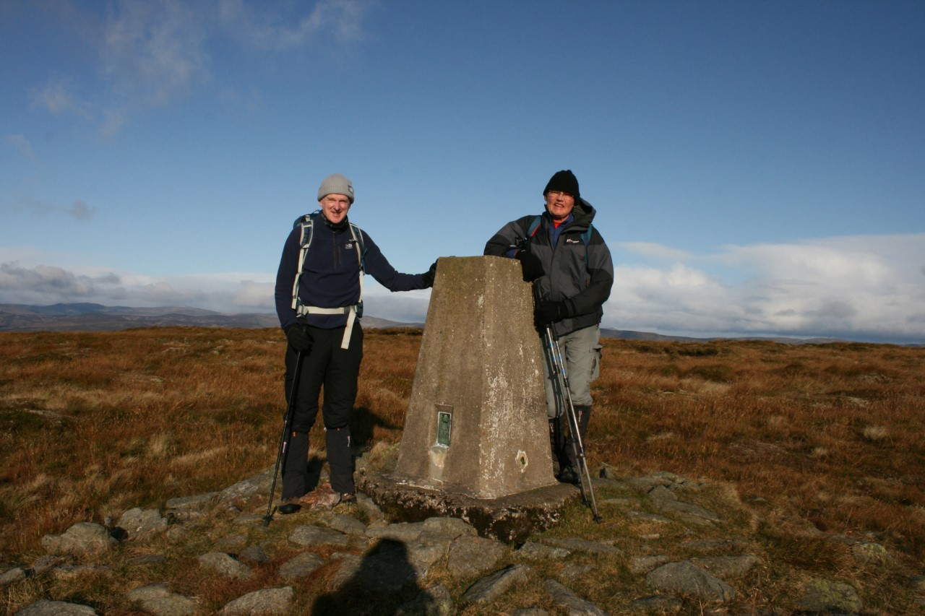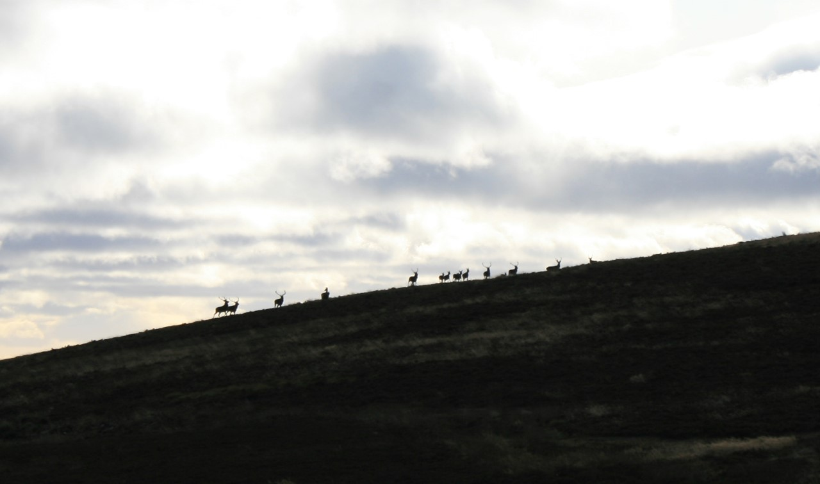 Cat Law Summit and same day deer on Corwharn
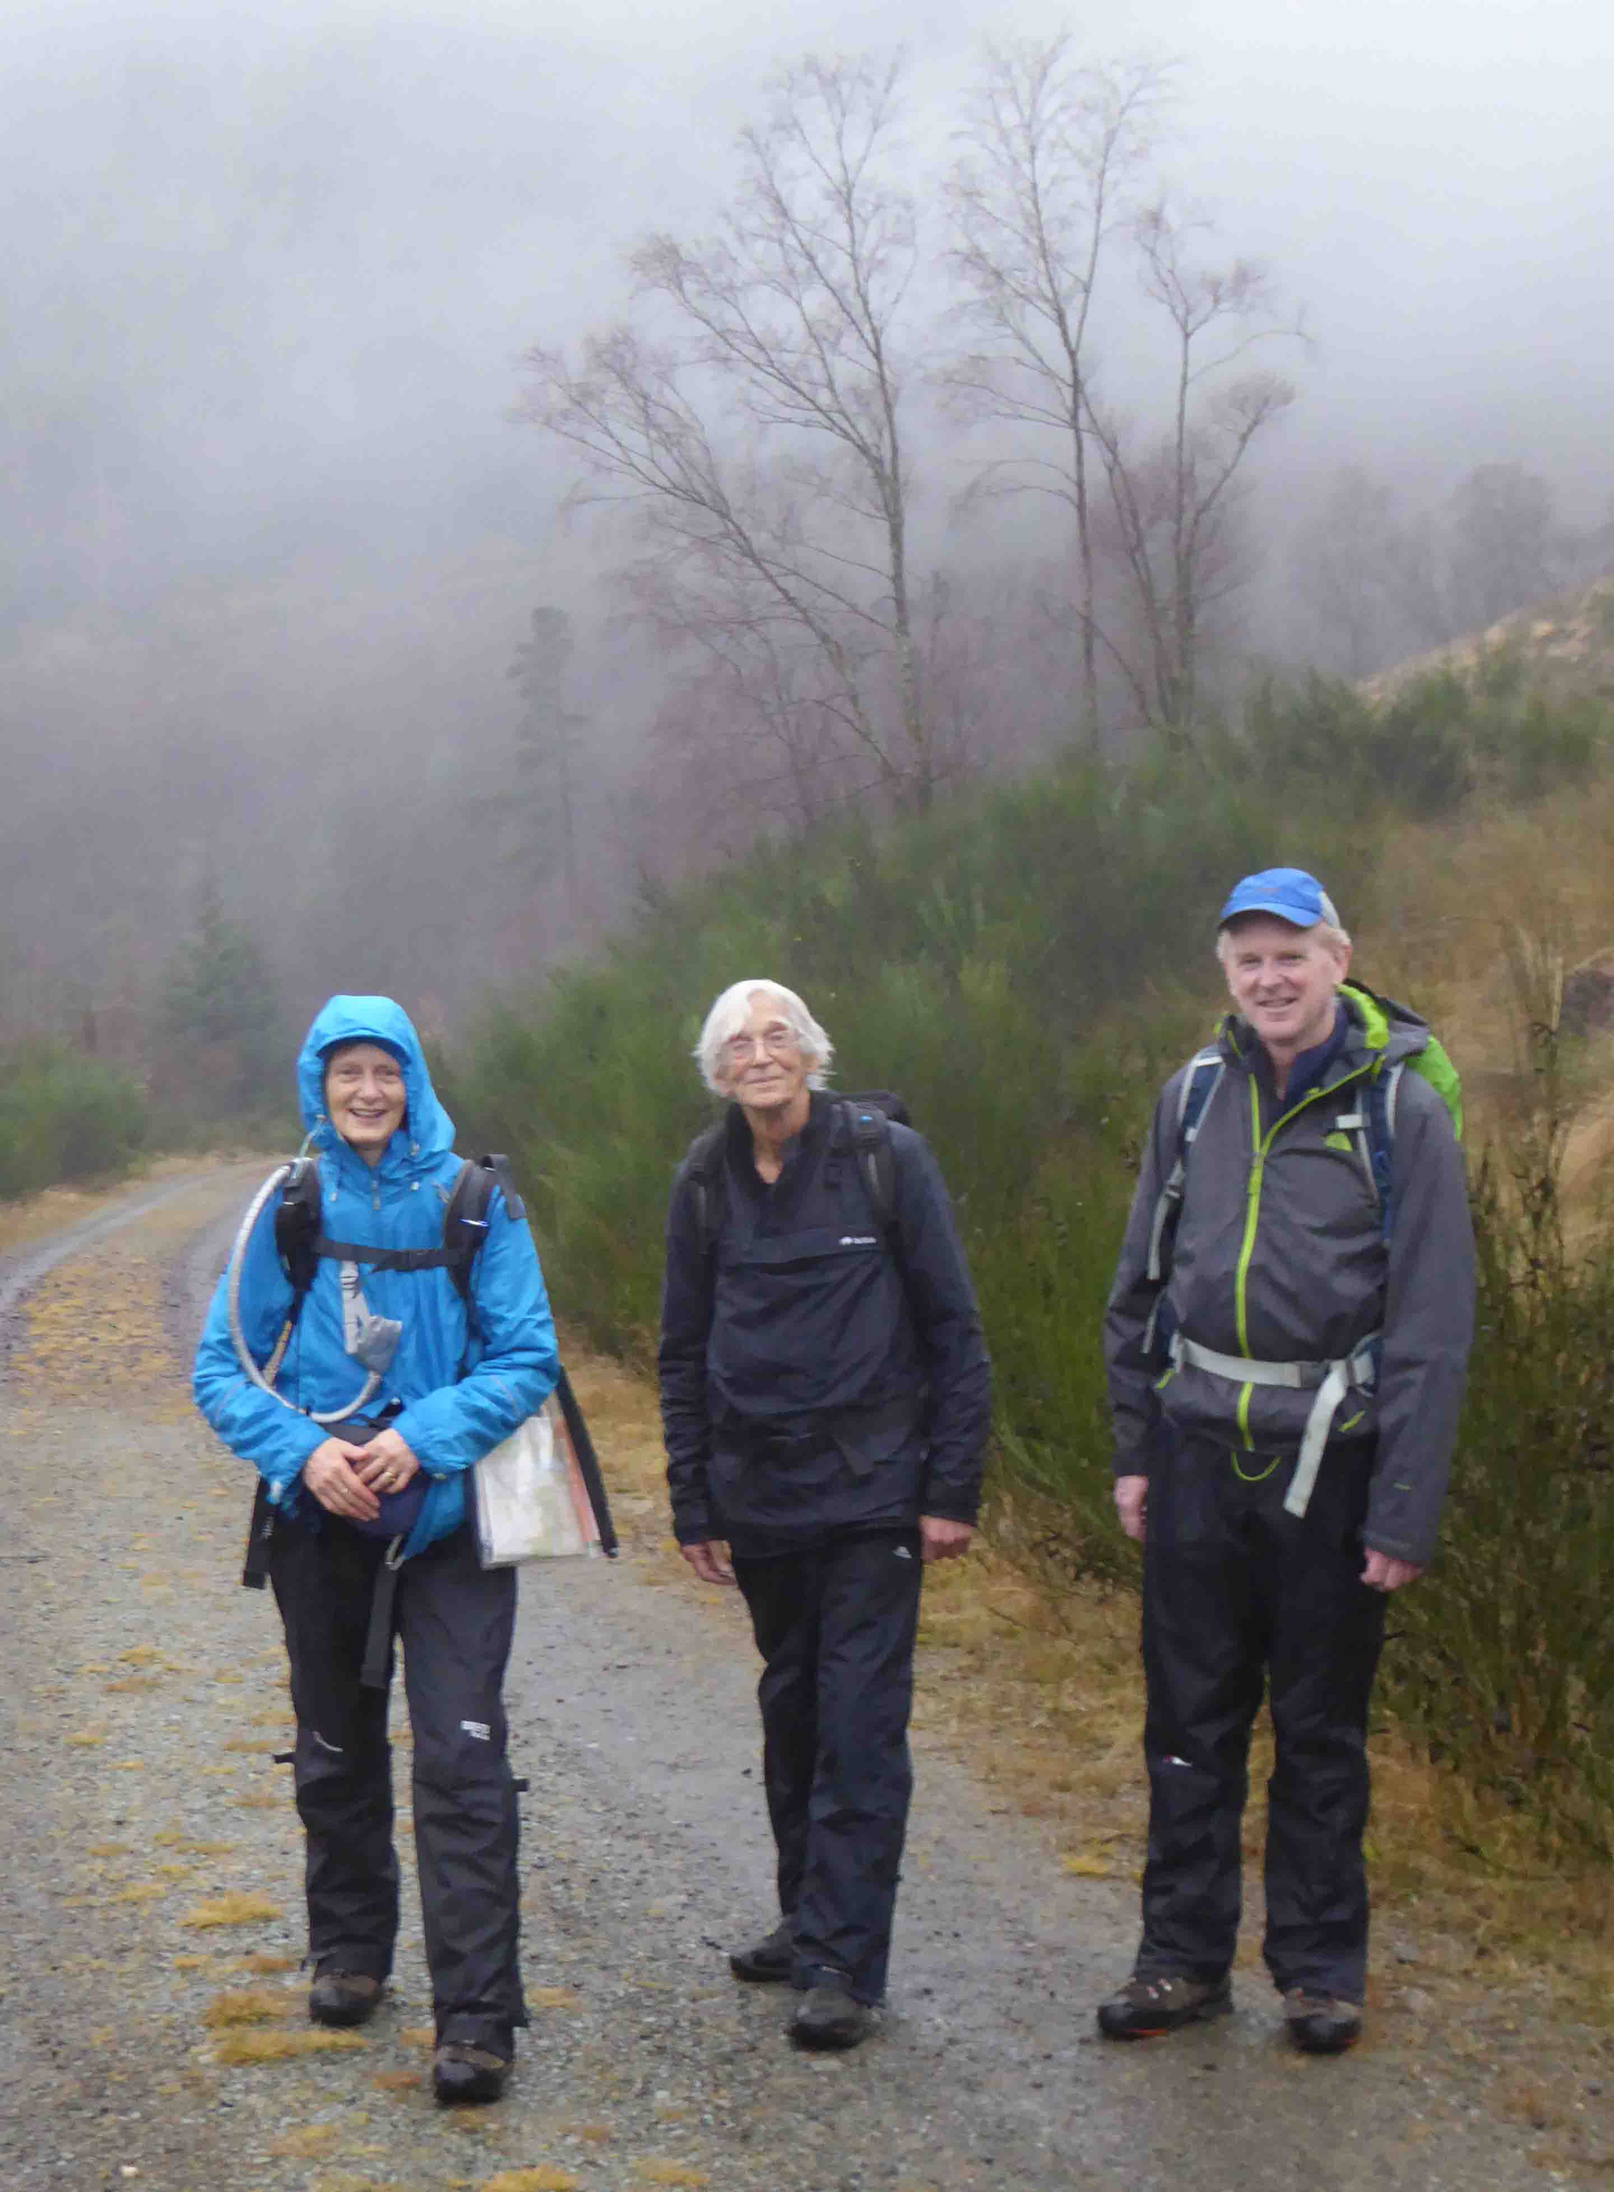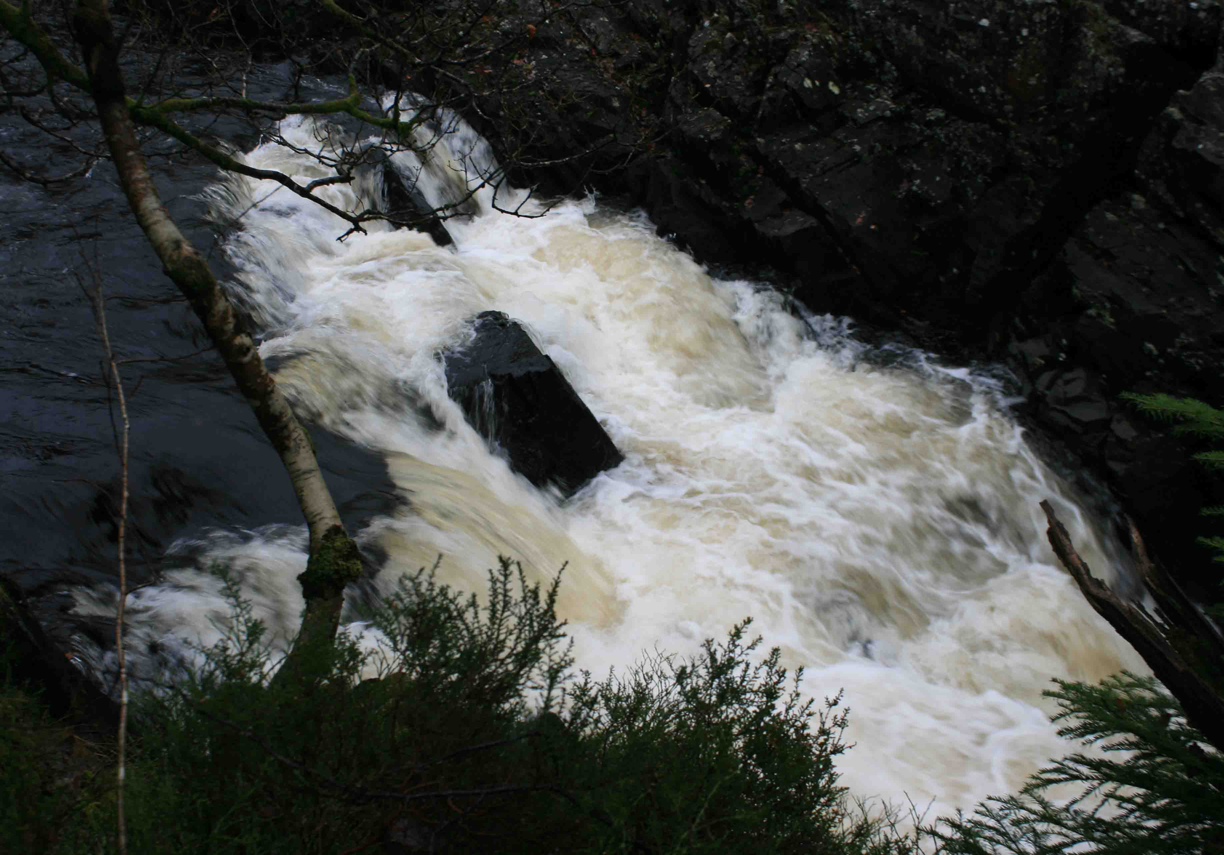
A damp walk on the Rob Roy Way by the Falls of Leni
A group of us, which included the most regular walkers, met in mid November and planned the Meet List for 2020 and have tried to make sure that any hill or area that was on this year’s list but which, because of weather, was modified such that it didn’t happen is included on the new list. The first outing of 2020 will take the form of the usual New Year trip to Barry Buddon with a walk through the Army Range from Monifieth out to the beach area near the light house where some of us attempt to cook our lunch on an open fire on the beach. I will coordinate that walk. Please can you let me know by lunch time on Hogmanay if you hope to come so that I can coordinate transport and also know who I need to contact to discuss any possible weather related change of plan.
The AGM will take place at Hope Park Church Hall, St Andrews on Tuesday 21st January at 7.00pm. After the formal business there will be the usual quiz. The AGM is also a chance to discuss where members would like to go for the summer week away and any possible weekends. These are a chance to go further afield than is feasible for a day outing from Fife. Please can you come with your ideas and any dates that you know you can or can’t manage.
Jean

