Fife Mountaineering Club Newsletter December 2015
After the Summer, which will be remembered for its miserable weather but also for a very successful Club week to Rum and a fine weekend for Les and Irene’s final Corbett celebration on Corryhabbie Hill, the Autumn has proved to be a quieter time for the Club. There were however two memorable days of perfect weather when Lochnagar and its neighbours were climbed in September and Meall nan Tarmachan in November.
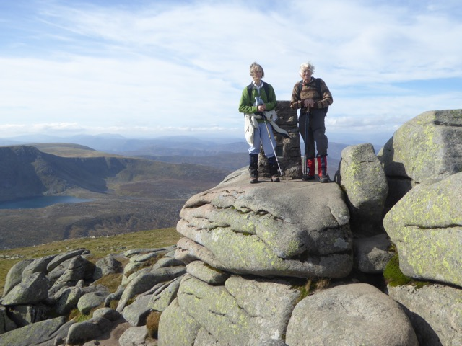 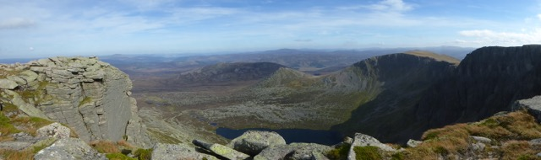above: the summit and also the view from the summit of Lochnagar
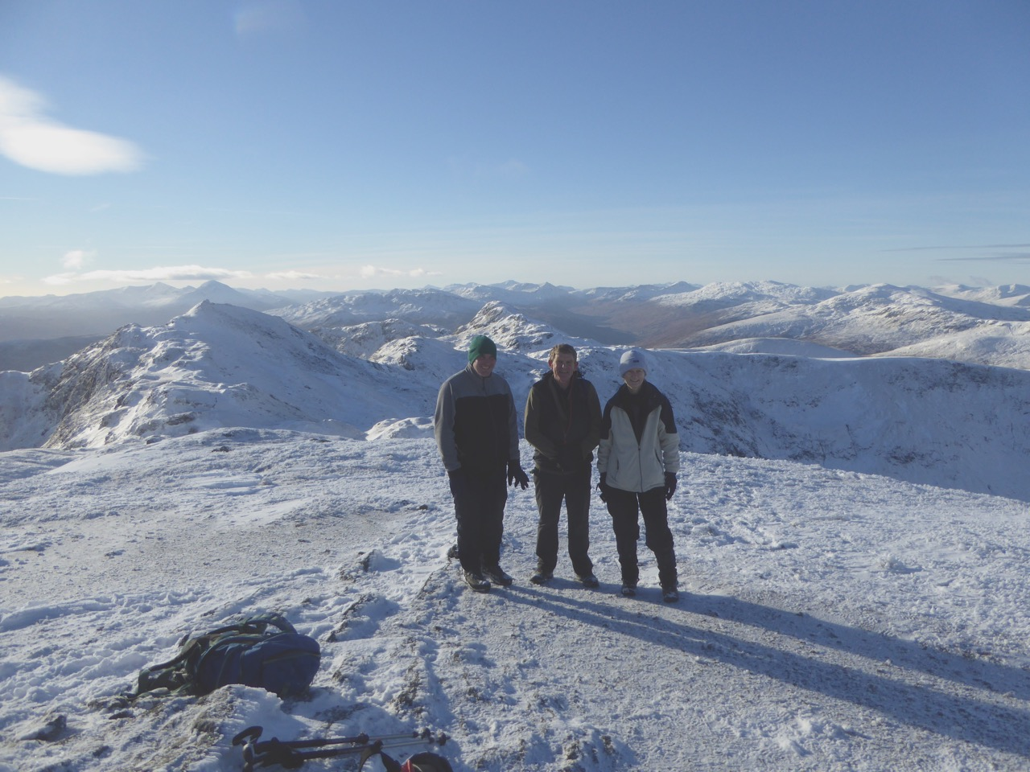 on Meall nan Tarmachan
You can see from these photos that those two days really were good. I think there may have been another outing that happened for which no report or photo was submitted. However given that much of September and October had beautiful settled weather the Club seemed to be unlucky in the way in which the advertised meet dates seemed to hit off the few days when the forecast was dire. I recall a number of us being interested in going on the planned Saturday outing to the Ben Lawers area in September but then being faced with a forecast which was good for the Friday and Sunday but horrible for the Saturday. By then we all had other plans for the Sunday and were unable to change the day and so that outing was cancelled. The same sort of thing happened for Ben Chonzie in October. I had 2 beautiful days out in October on Ben Chonzie and in the Ben Lawers area but I had been able to be flexible and choose days when I knew the forecast was good. I also had a good week over in the West during the first week of September. I know that some of us, who not as young as we once were, no longer feel so enthusiastic at the prospect of setting off to climb a hill we have climbed several times before with a forecast of persistent rain and wind speeds at 3000ft of greater than 40mph. After this frustrating spell we do still remain optimistic that 2016 will be memorable for its fine settled sunny weather and with this in mind six members met in November and planned the Day Meet list for 2016. This is attached.
When I wrote the last Newsletter many of us who had been on Rum came back feeling they had achieved successfully a lifelong ambition and with renewed enthusiasm such that one member was even inspired to submit a poem on the experience. This should have gone in the previous Newsletter but it just happened that it was given to me written on paper at a time when I was having people at short notice wanting to view my house. All sorts of things including piles of papers then were quickly hidden away somewhere out of sight in weird places. Finding things continues to be a problem but this has since resurfaced and is shown below:
We gathered in Mallaig We walked, we talked, happy and excited, we ate, we drank, in anticipation, we laughed, we joked, with expectation, we puzzled, one knitted! in trepidation. We gazed, amazed. We had fun. New hills to climb, Thank you Rum! new glens to tramp, old footsteps to retrace, old memories to share. (anon)
As I write this Newsletter on a miserable December evening it does bring back memories of the mood of 6 months ago.
Can those of you hoping to go on the 2nd January Barry Buddon Meet let me know so that I can coordinate transport. It is an outing where folk come from different directions, meeting up at Moniefieth so it is necessary to know who we are expecting to turn up there and also if the weather forecast leads to a change of plan we need to know who needs to be notified of this.
Finally I look forward to seeing as many of you as possible at the
AGM on Wednesday 20th January 2016 in St Andrews Town Hall at 7.00pm. PTO
This will take the usual form of the formal business being followed by a quiz organised by last year’s winner who was Peter. Please also come with ideas as to where you would like to go for the 2016 Club week and for any weekends.
Jean

