Picos De Europa

1) This is the Cares Gorge, the ‘jewel in the crown of Spanish hiking’.  Engineered in the 1940’s the path was blasted into the rock as part of a hydroelectric scheme and is now one of the most popular walks in Spain.  Peaks on either side reach over 2,000 metres.

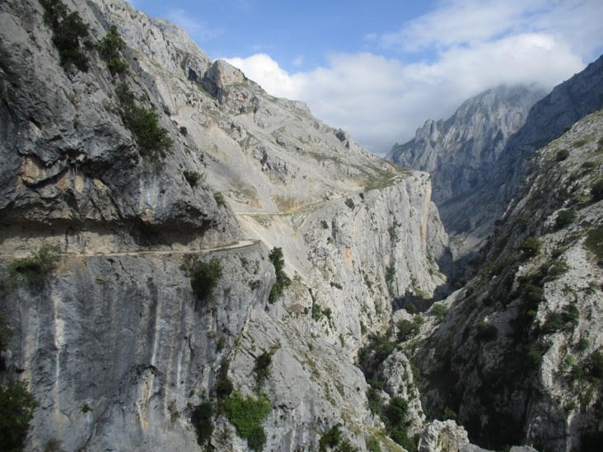

2) During a lunch break during a hike to San Carlos peak.  This followed old, disused mining tracks and is part of the Eastern Massif of the Picos.

